Notes for project 1

Why is there no check for n being null in insert????

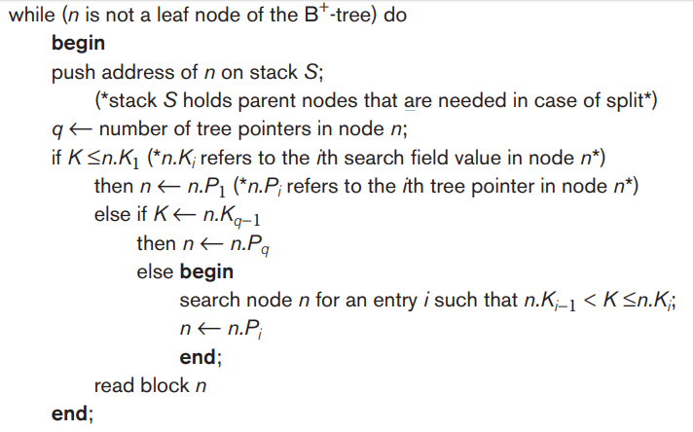- Insert, I think the else if K 🡨 n.Kq-1 should really be K > n.Kq-1, also wondering if the q-1 should be a q but maybe not because it’s saying that as long as it’s bigger than the second last one then it should automatically be pointed towards the last one